FRESHERS' PARTY ON 17TH OCTOBER 2016
Aravali College of Advanced Studies in Education
Notice : 7th October, 2016
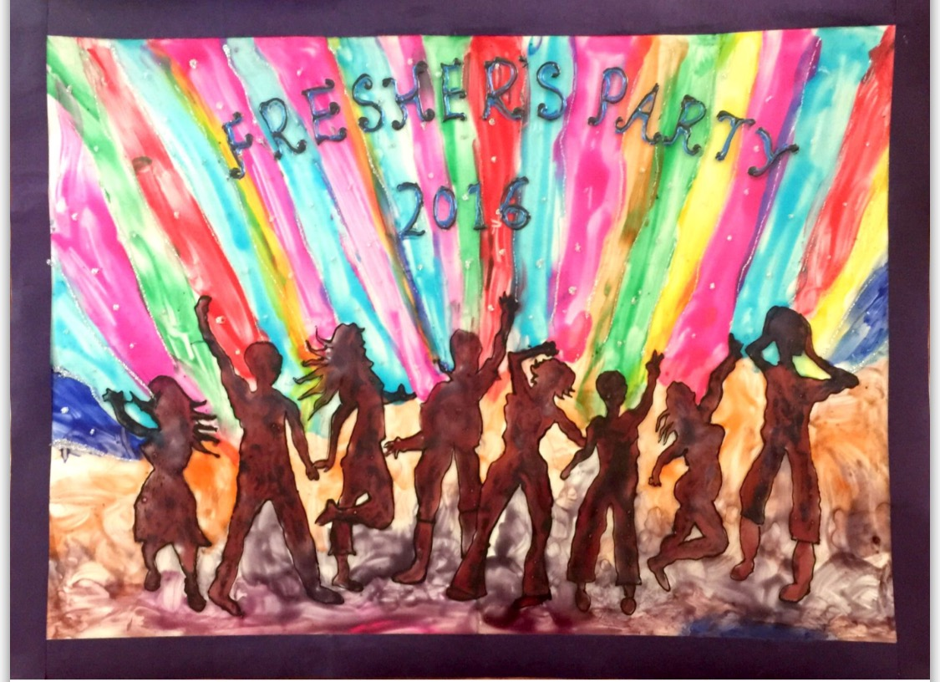
All the B.Ed and M.Ed first year students are notified that that the college is conducting a FRESHERS' PARTY on 17th October, 2016 in the campus. There will be a cultural programme and crowning of Mr. Fresher and Ms. Fresher. We invite you to attend the event and make it a success. Interested participants can give their names to Ms. Meenu 9971081881

